**Tuition Class Tute Registration System – Logical Design**

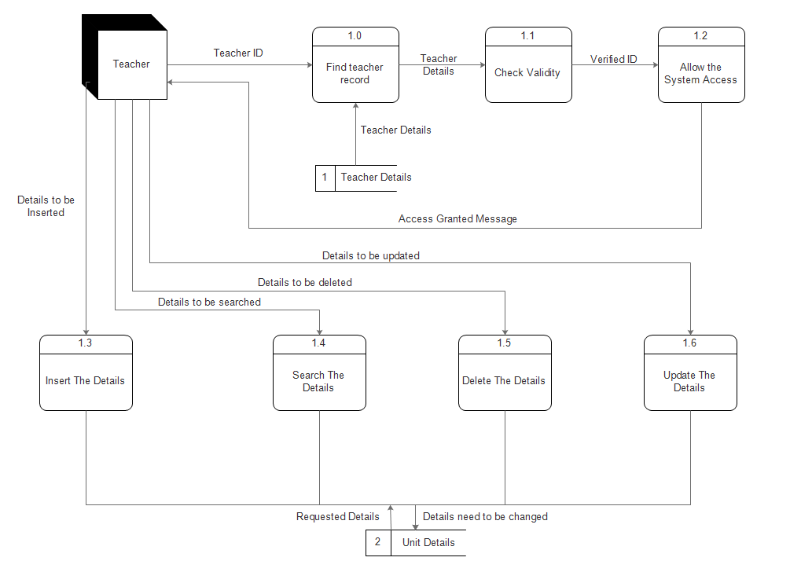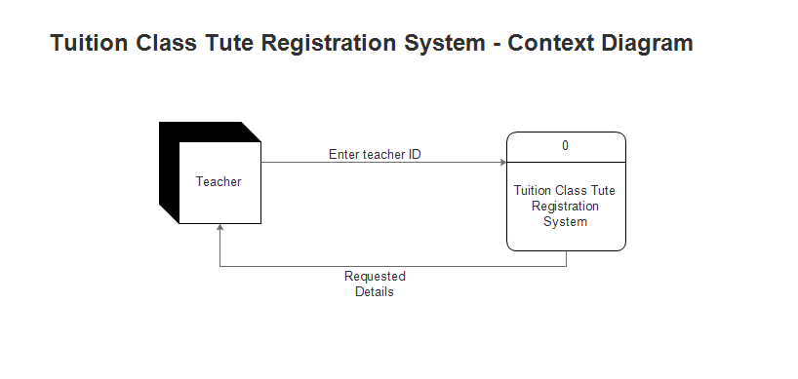

**Tuition Class Tute Registration System – DFD**